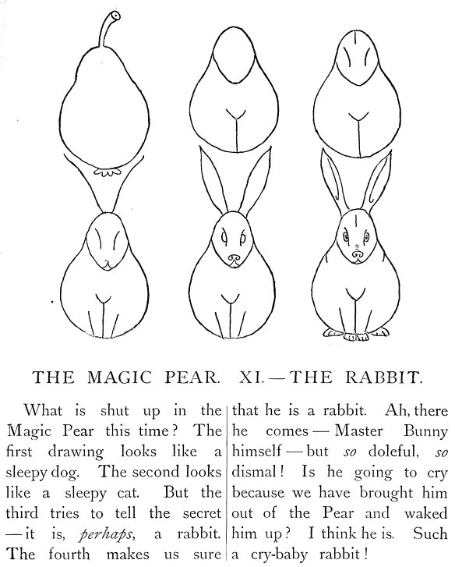 | A DRAWING LESSON and A WRITING LESSON  How to draw a rabbit.  ______________________________________________________________
  1 Here is the figure of a rabbit.  _____________________________ | 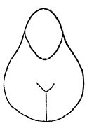  How to make bunny's ears with a keyboard  (\ /) (\ /) (\ /)
  2 The eyes and the forhead
  ____________________________
  3 The two long ears
  _____________________________
  4 The face with nose and mouth
  _____________________________
  5 The four feet
  _____________________________

