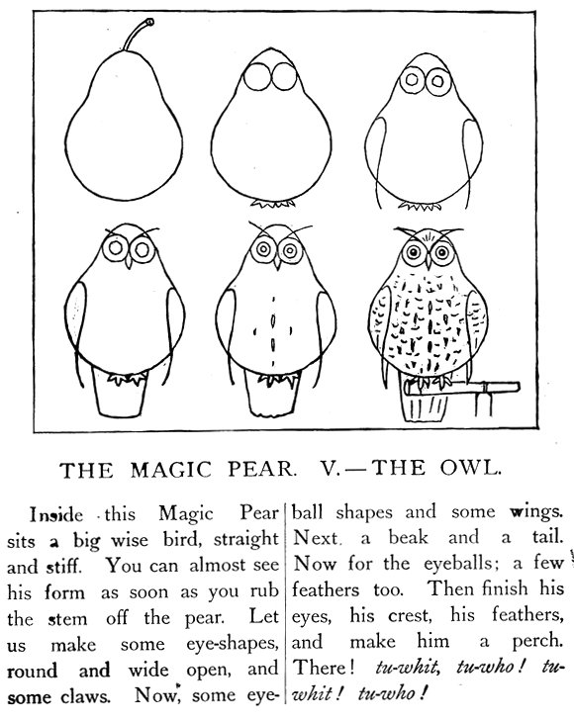 | A DRAWING LESSON, and A WRITING LESSON  In this magic pear, there is a night-bird, an owl.  In _______________________________________________________________  In English, the owl sings Tu-whit, Tu-who !  In English, _________________________________________________________
  1 Here is the pear !  ______________________ | 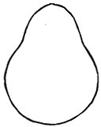
  2 Two circles ________________
  two feet __________________
  3 Small circles ________________
  two wings __________________
  4 The beak __________________
  the tail ____________________
  5 The eye-balls _______________
  feathers ___________________
  6 The crest ___________________
  body-feathers ________________
  a perch ________________

