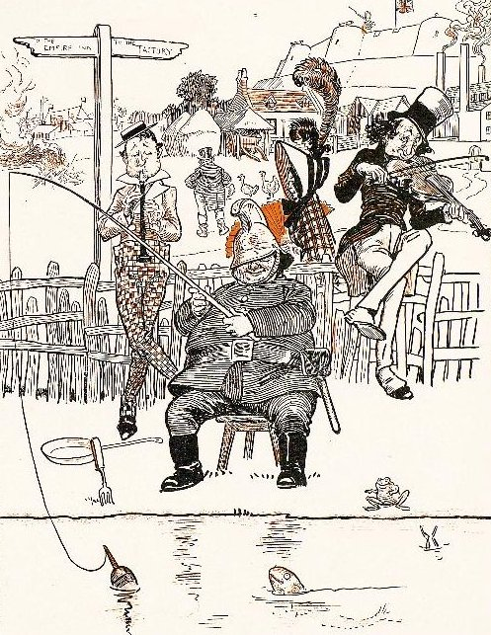  source : BROWNE, Gordon (1858-1932),  Dr Jollyboy's ABC, 1898  http://ufdc.ufl.edu/UF00087351/00001 | WHERE ARE THEY ?  Find out each of them in the drawing.
  A fireman is fishing with a float.
  A fish and a frog are watching him.
  A fork and a pan are waiting.
  A fiddler is sitting on the fence and playing the violin.
  A flute-player is blowing in his flute.
  The fair lady has a fan and big feathers on her hat.
  A fat farmer is feeding his fowls.
  He is walking to his farm.
  A finger-post is pointing its finger to THE FACTORY.
  There are three chimneys at the factory.
  There is a British flag at the fort.

