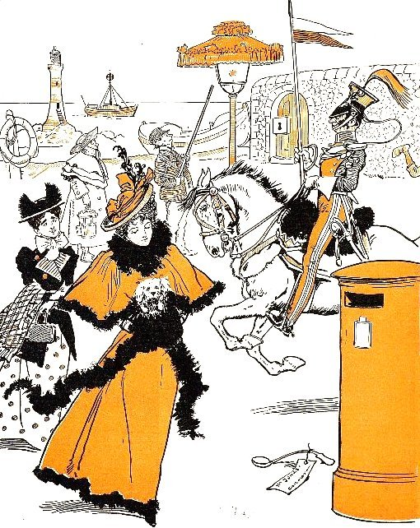  Source :  Browne, G. (1858-1932), Dr Jollyboy's ABC, 1898, http://ufdc.ufl.edu/UF00087351/00001 | WHAT CAN WE SEE ?  There are five characters on this picture.  A lady (and her lapdog) with a lady's maid,  a lancer on his horse,  and a lamplighter with his help.  What are they doing ?  The two ladies are walking to a letterbox.  The lancer is riding his horse, a lance in his right hand.  The two men are watching a lamp with a big lampshade.  Now it's your turn.  Write about the sea-side : lighthouse, lifeboat, lifebuoy, lightship  _______________________________________________________  _______________________________________________________  _____________________________________  Other ideas ? : lock, leg, label...  _________________________________________

