Browne, Gordon, 1858-1932  Dr Jollyboy's ABC, 1898  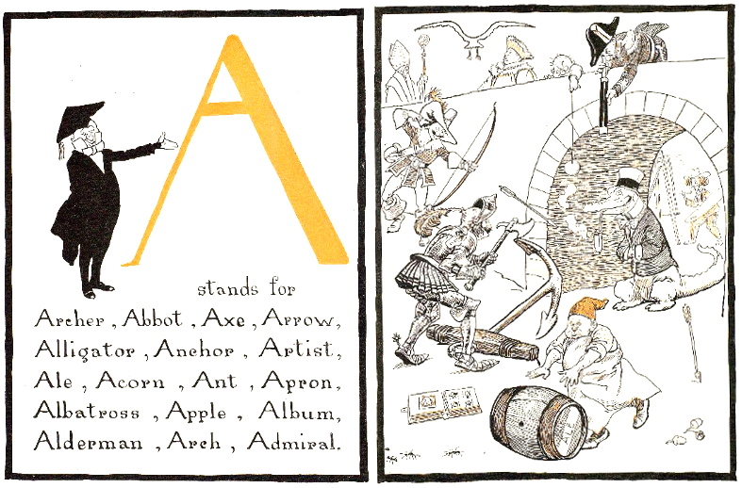  http://ufdc.ufl.edu/UF00087351/00001 | WHO ARE THEY ? WHERE ARE THEY ?  Put a number from 1 to 12 on their drawings
  The archer and his two arrows
  The alligator smoking a pipe under the arch
  The admiral and his telescope
  The artist painting the scene
  The albatros in the sky
  The apple hanging
  The three acorns of an oak-tree
  The four black ants running away
  The man with the axe
  The anchor and no boat
  An album with images
  The man in an apron, with a barrel of ale

