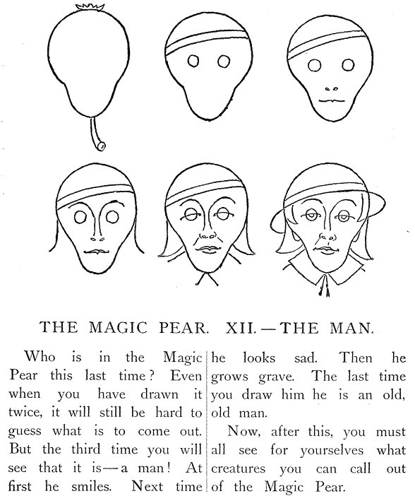 | A DRAWING LESSON and A WRITING LESSON  How to draw smiling faces...  _________________________________________
  1 Here are three figures of faces.  _____________________________  Draw them as you wish to. | 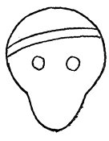  SMILEYS, Gnomine-icons.png
  2 The eyes and the eyebrows
  ____________________________
  3 The noses and the nostrils
  _____________________________
  4 The mouth … and a moustache ?
  _____________________________
  5 The ears, the hair...
  _____________________________

