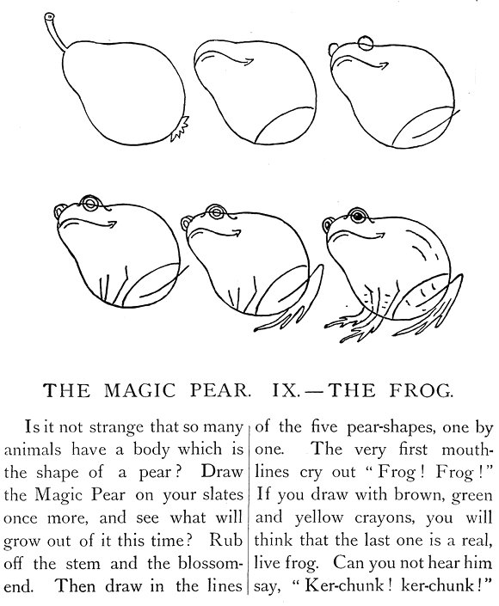 | A DRAWING LESSON and A WRITING LESSON  How to draw a frog from a magic pear.  ______________________________________________________________
  1 Here is the form of a frog !  _______________________________ | 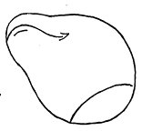  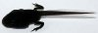  The baby-frog, a tadpole  http://commons.wikimedia.org/wiki/File:Tadpole_3.JPG
  2 Two circles for the eyes
  _____________________________
  3 A back-leg
  __________________
  4 Two fore-legs
  _______________________
  and two portruding eyes
  _______________________
  5 The frog is singing Ker-chunk !
  _______________________________

