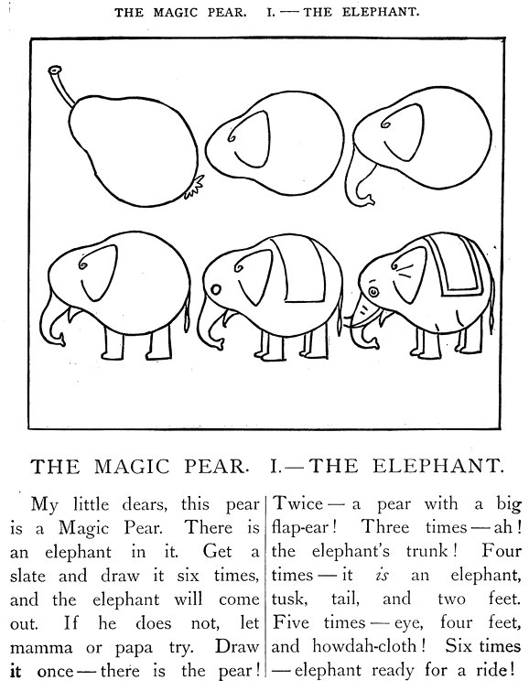 | A DRAWING LESSON  This pear is a magic pear. There is an elephant in it.
  1 There is the pear ! | 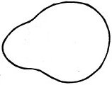
  2 A pear with a big flap-ear !
  3 The elephant's trunk
  4 A tusk, a tail, and two feet
  5 An eye, four feet, the cloth
  6 Ready for a ride !

