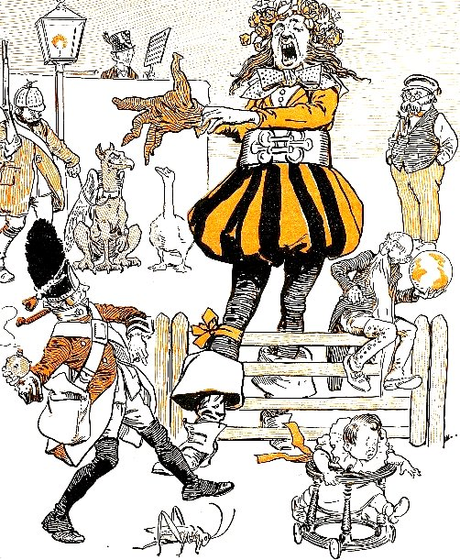  Source : Browne, G. (1858-1932), Dr Jollyboy's ABC, 1898  http://ufdc.ufl.edu/UF00087351/00001 | WHERE ARE THEY ?  Find each of them in this drawing :
  Gargantua the giant is pulling a glove to his right hand.
  He has a large girdle and a small garland on his right knee
  A grenadier is throwing a grenade at him
  A grasshopper and a baby in his go-cart are running away
  A griffin and a goose are watching him.
  A gamekeeper with a gun is holding the leash of the griffin.
  A grey-beard man is sitting on the gate and holding a globe.
  A groom is standing near the gas-lamp.
  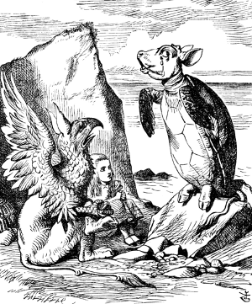 | Alice in wonderland,  between the Griffin and the Mock-Turtle.  http://commons.wikimedia.org/wiki/File:Alice_par_John_Tenniel_34.png

