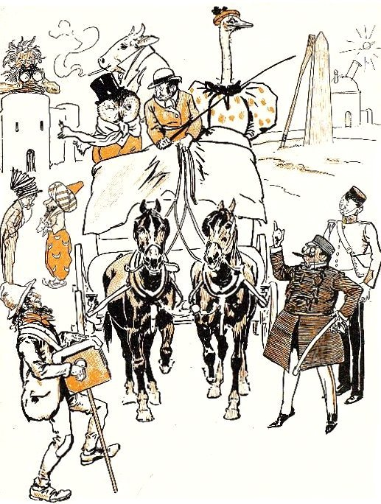  Source : Browne, G. (1858-1932), Dr Jollyboy's ABC, 1898, http://ufdc.ufl.edu/UF00087351/00001 | WHO ARE THEY ? WHERE ARE THEY ?  - Complete the sentences with the words :  OMNIBUS, OGRE, OFFICER, OSTRICH, OWL, OX, OPERA-HAT, OPERA-GLASS  An organ-grinder is playing the _______________  The omnibus is carrying three animals : _______________, _______________,  and ______________________. They are going to the opera.  The __________ is smoking a cigarette.  On the owl's head, there is a black ____________________  The _______________ is drawn by two black horses.  An _______________ with glasses and a stick, is smoking the cigar.  An _______________ is watching from his ogre's castle with._______________

