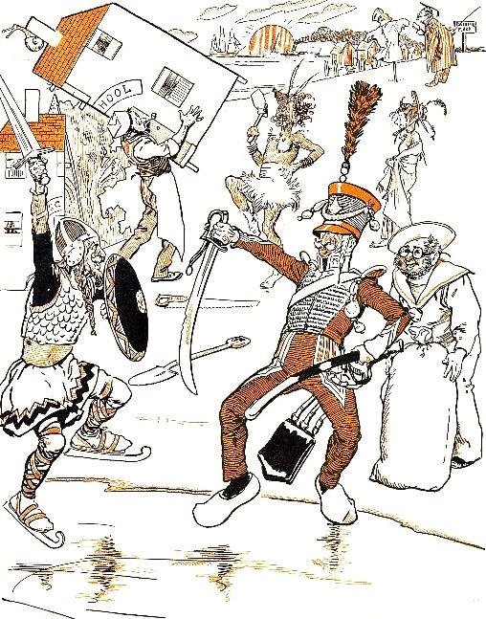  Source :Browne, G. (1858-1932), Dr Jollyboy's ABC, 1898, http://ufdc.ufl.edu/UF00087351/00001 | WHO ARE THEY ? WHAT ARE THEY DOING ?  - Complete the sentences with one of these seven words.  SWORD, SAVAGEMAN, SAILOR, SOLDIER, SCARECROW, SCHOOL, SABOTS  A scene-shifter is carrying away the half of a __________________.  A viking _____________ has skates on his feet and a _____________ in hand.  He is fighting against a shako with a sabre in hand and _________ on his feet.  A ______________ with glasses is watching the two men fighting on the ice.  A school-teacher is talking to a ________________.

